EXPLOROTARY DATA ANALYSIS ON TERRORISM IN INDIA

# GATHERING THE DATA

I have got my data from a very trusted source , Global Terrorism Database, (<https://www.start.umd.edu/gtd/>).

# UNDERSTANDING THE DATA

The gathered data contains column of date, city, perpetrator group, fatalities and injured.

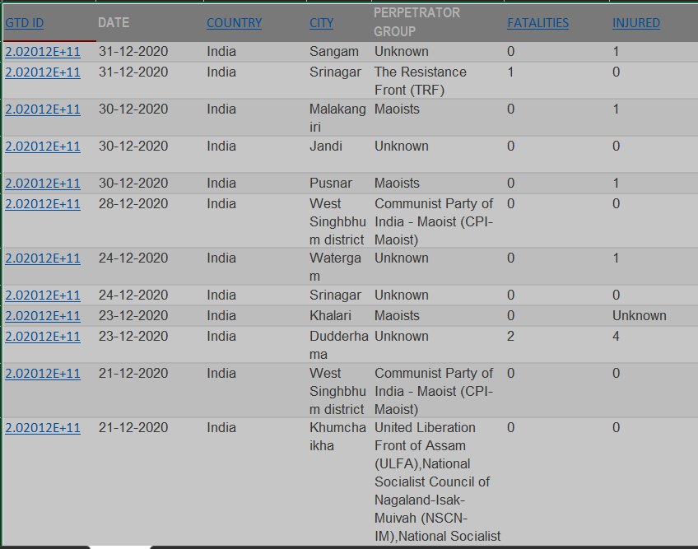

This is just an example as we have gathered over 180 columns of data in this format. We also have some Unknown data, but we will leave it as that so we gain results with more accuracy compared to with less data.

# DATA CLEANING

From there I updated the data into a excel file and then did the normal data cleaning process, which included converting it into a .csv file, clearing the null values, then creating a new column for injuries and fatalities as INJ AND FAT, also changing the layout to make it easily accessible.

The cleaned data looked like this

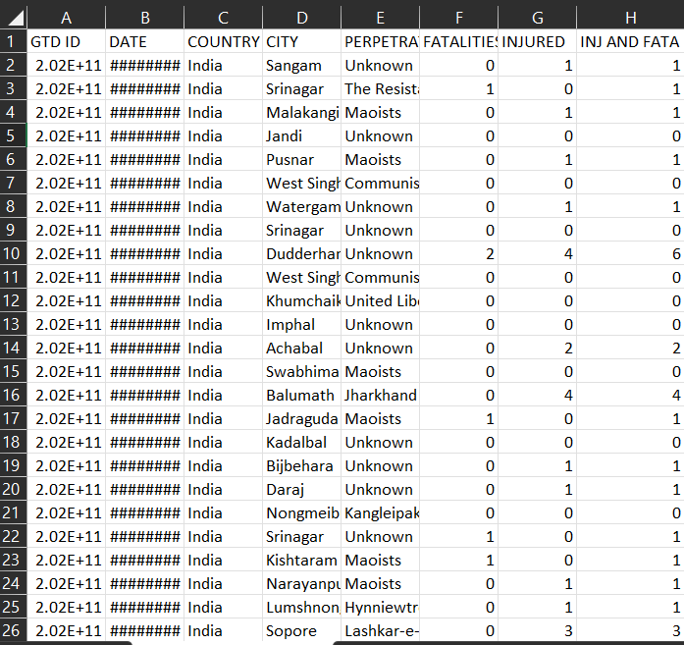

# VISUALIZATION

After gaining the cleaned data I wrote python code for visualising data through graphs

## SORTING TO FIND OUT WHICH PARTY HAS CAUSED THE MOST DAMAGE

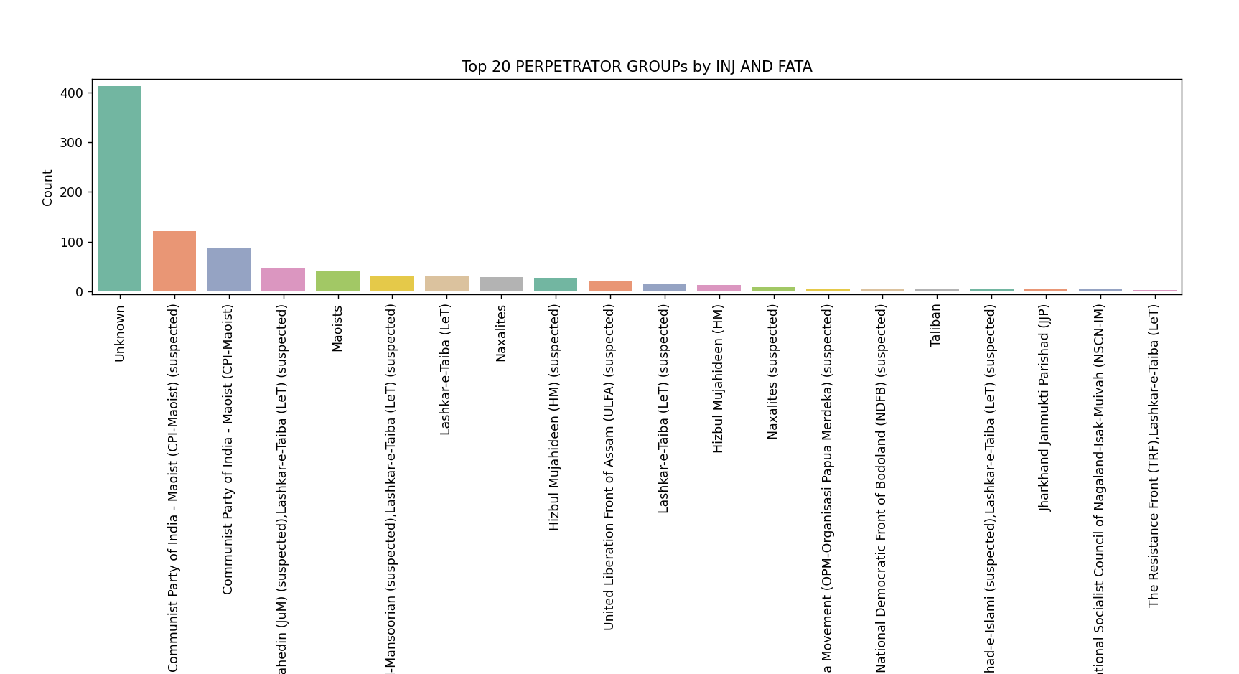

With the above data we can come to the conclusion that the injuries \ fatalities caused by terrorism are mostly unknown in India

The communist party of India has been the first party (excluding the unknown data) in the list of being the most violent.

## FINDING THE MOST DANGEROUS CITY IN INDIA

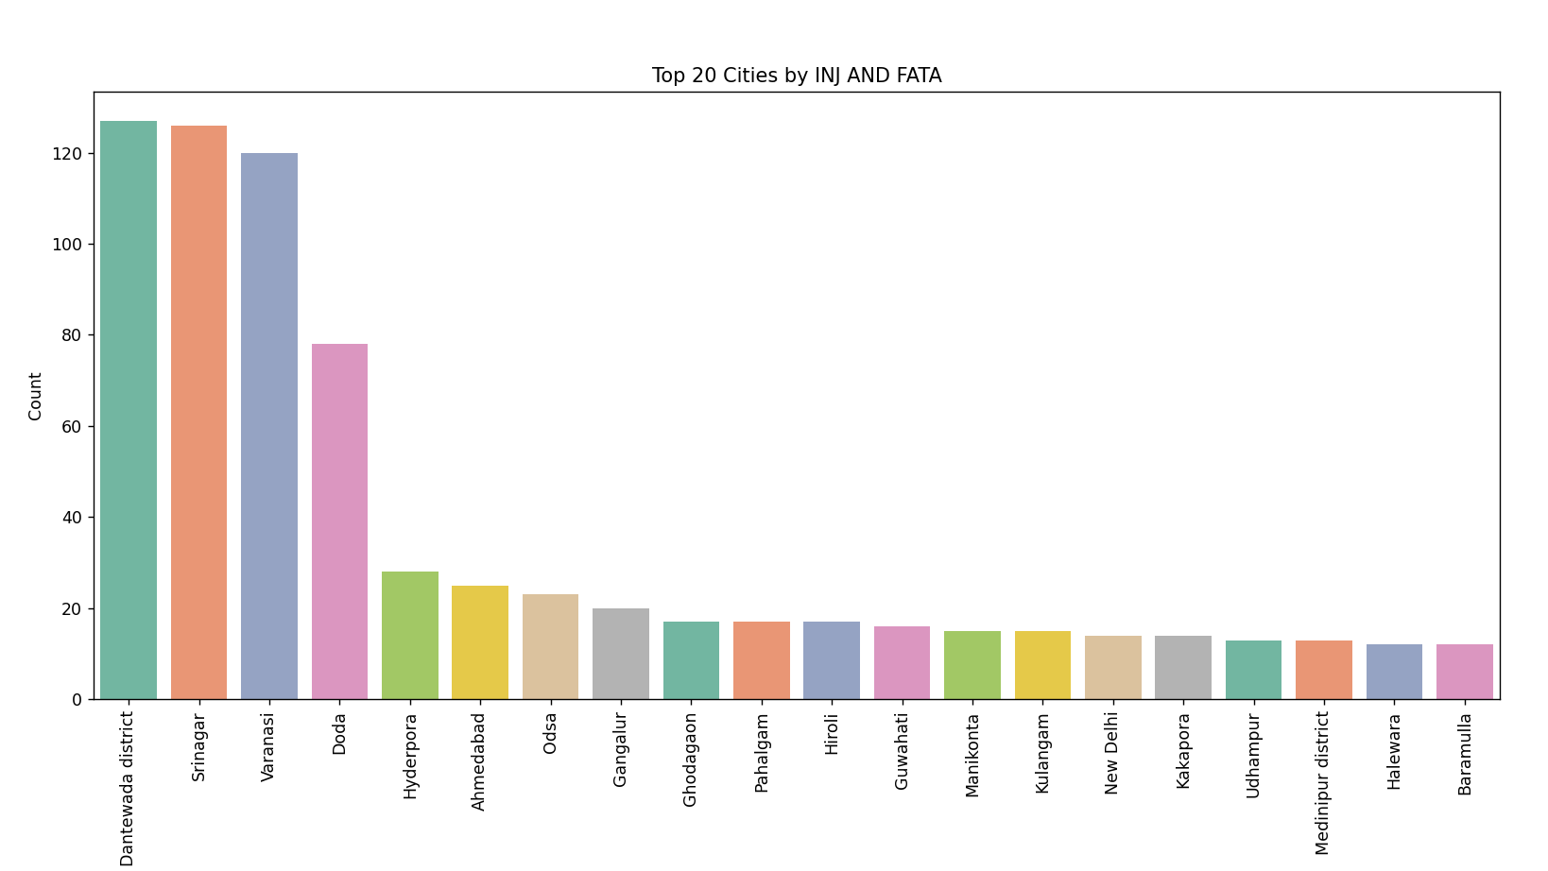

From the above bar chart we can get to the conclusion that the most attacked place in India by terrorism is Dantewada district, followed closely by Srinagar.

Form that we can conclude it is not safe to live in these parts of India.

# INJ AND FATA OVER TIME IN CITIES

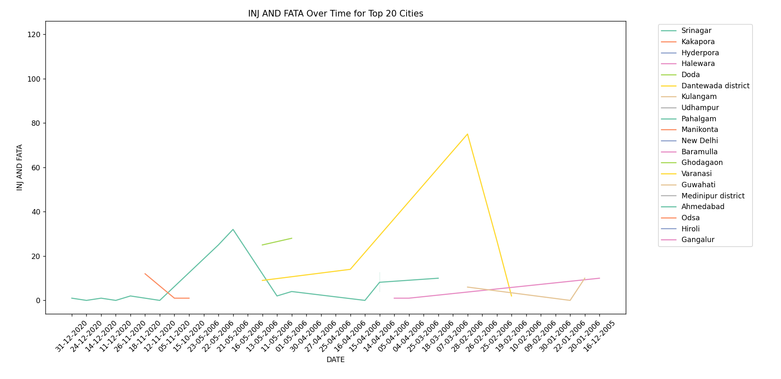

From the line chart we can observe that the Dantewada district has caused the most injuries or fatalities over the time period from 25/2/2006 to 16/4/2006.

It is safe to say that the terrorists attacks has be very little nowadays.

Ahmedabad has experienced the most recent terrorist attack as of the availability of data taken.

## LEAST VIOLENCE PERPETRATOR GROUP

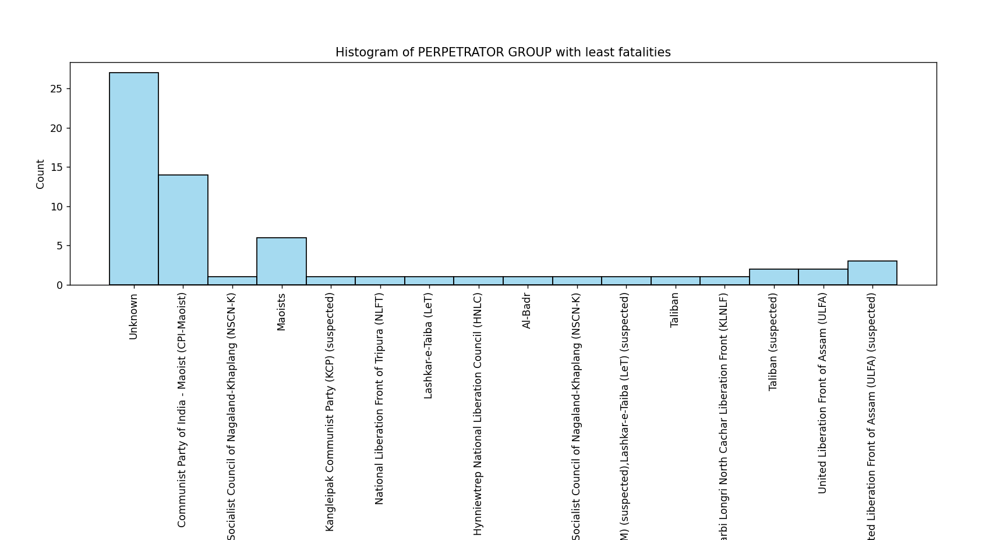

From this graph alone we cannot conclude that CPI is the least violent party as they also have the most injuries and fatalities.

This data proves that from the ratio of their attacks. That is the perpetrator group has attacked the most is likely to have the most in both violence and non violence simply due to the sheer amount of times they had attacked in the past.

After comparison we can conclude that NSCN-K is the least violent party of terrorism that has attacked India in the past.

# SUMMARY

* The amount of official data which has the Perpetrator group identified is very low as UNKNOWN is a common situation we are frequently seeing
* From the data we can very well conclude that the Communist Party of India had been a frequent trouble causing group In India
* Places like Dantewada district and Srinagar has suffered the most in the past in means of attacks due to Terrorism.
* Dantewada and Ahmedabad has been a big target for the terrorism Groups over time.
* The terrorism attacks had been reduced quite a lot when comparing to the past
* Although the threat of terrorism is fatal, there are some parties which has not caused as much or very less injuries when compared to others. Eg:- NSCN, ULFA

# CONCLUSION

* Terrorism is greatly reduced in India over the course of time
* Places with polar Political, Religious pressures has been the most affected
* The communist party has the most dangerous perpetrator group to have attacked India
* Dantewada and Ahmedabad must be increased with defence forces to avoid further attacks.
* The south of India has been pretty safe from the Terrorism occurred in the past
* No terrorist group has made repeatedly large impact after they had been dealt with once.

# PROGRAMMING LANGUAGE USED

I have been my knowledge in Python to clean the data and visualize the data. I have used libraries like

pandas, numpy, seaborn, matplotlib

THANK YOU